Evaluation: Provincial Stroke Rounds – December 1st, 2021
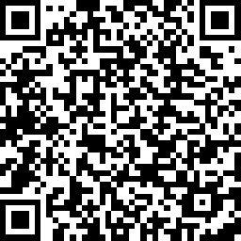
Topic: Risky Behaviours After Stroke: How Can we Support?

Presenter: Martina Nuttall, RN, Michelle Allain, Bioethicist, Christina Johnson, NP

Online Evaluation Link: https://www.surveymonkey.com/r/7SXYYCF QR Code:

Stated Presenter Objectives - Upon Completion the participants will be able to:
- Identify stroke best practices that relate to substance abuse post-stroke
- Describe ethical principles when engaging with stroke patients regarding risky behaviours
- Apply harm reduction and health teaching principles to stroke patients in the acute and secondary prevention stroke environment

- Please indicate your discipline:
☐ MD | ☐ OT | ☐ Recreation Therapist
☐ Medical Resident | ☐ PT | ☐ SLP
☐ Physician Assistant | ☐ OTA/PTA | ☐ Administrator
☐ NP | ☐ Social Work | ☐ Educator
☐ RN | ☐ Pharmacist | ☐ EMS
☐ RPN | ☐ Registered Dietitian | ☐ District Stroke Coordinator
 |  | ☐ Other

- This session enhanced my knowledge of:

Stroke Best Practice Recommendations ☐ Yes ☐ No
Knowledge of Current Research ☐ Yes ☐ No

- The presenters(s):

 | Strongly Disagree | Disagree | Neutral | Agree | Strongly Agree
Delivered their material clearly & effectively
Were effective in facilitating discussion
Provided adequate opportunities for interaction

- Did the presenter(s) meet their stated learning objectives? ☐ Yes ☐ No

- How will you apply knowledge gained from this session? List one or two things you will do differently.
- Was there an opportunity to be self-reflective? ☐ Yes ☐ No

- Did you perceive any degree of bias in the session? ☐ Yes ☐ No

IF bias perceived, please describe:

- Were you satisfied with use of technology? ☐ Yes ☐ No

- Suggestions for future stroke-related topics and speakers?/Additional Comments

